NATIONAL UNIVERSITY OF MODERN LANGUAGE ISLAMABAD
Lab 10


Submitted to:
Ms. Fatima Gillani
Submitted by:
Zulqarnain Hassan
Roll No: …………………… SP21379
Subject: …………………… SCD
Department: ……………… BSSE-5-Afternoon
Date: ……………………… 14-12-2024

Tasks: 01
ID | Input | Expected output | Actual output | Class | Status
Case-01 | The 4 hour workweek | Successful added | Successful added | Valid | Pass
Case-02 | HW | Failed | Failed | Invalid | Pass
Case-03 | 456 | Failed | Failed | Invalid | Pass
Case-04 | The 4$ hour workweek | Failed | Failed | Invalid | Pass
Case-05 | Where Are the Children" by Mary Higgins Clarke (mystery) What Color is Your Parachute" by Richard N. Bolles (self-help)  "Is Google Making Us Stupid?" by Nicholas Carr (thought-provoking work) | Failed | Failed | Invalid | Pass

Task: 02
Exception Handling Task
Arithmetic Exception
package lab10;

public class Lab10 {

public static void main(String[] args) {
// Arithmetic Exception
try {
int a=9;
int b=0;
System.out.println("division of a and b is= "+a/b);
}catch(ArithmeticException e) {

System.out.println("Arithmetic Exception handled ");
}
}

}
Output:
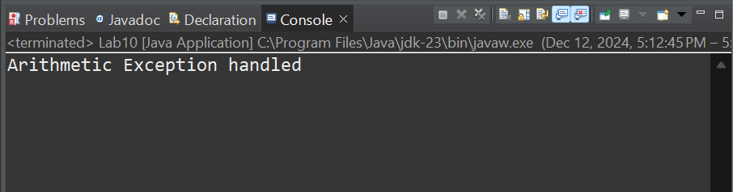

Array Index out of Bound Exception
package lab10;

public class task1 {
static void validate(float salary) {
//Array Index out of Bound Exception
try {
int[] arr=new int[10];
System.out.println("value at 12 index = "+arr[12]);
}catch(ArrayIndexOutOfBoundsException e) {

System.out.println("Array Index Out Of Bounds Exception");
}
}
}
Output:
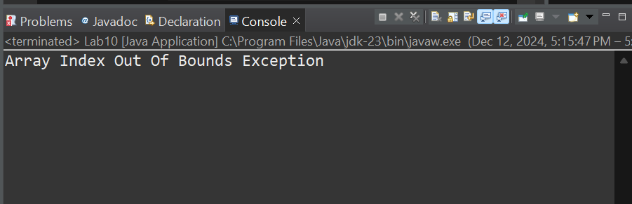

Multiple catches
package lab10;

import java.util.InputMismatchException;

public class task3 {
public static void main(String arg[]) {

// Multiple catches
try {
int[] arr=new int[10];
System.out.println("value at -8 index = "+arr[-8]);
}
catch(ArrayIndexOutOfBoundsException e) {

System.out.println("exception handled"+e);
}
catch(InputMismatchException e) {

System.out.println("exception handled"+e);
}
catch(Exception e) {

System.out.println("exception handled"+e);
}
}
}
Output:
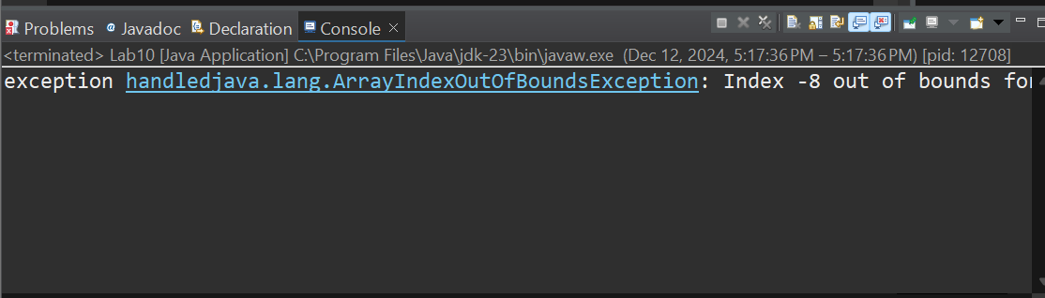

Input Mismatch Exception
package lab10;

import java.util.*;

public class task4 {

public static void main(String[] args) {
Scanner sc=new Scanner(System.in);

//Input Mismatch Exception

try {
int number=sc.nextInt();
System.out.println("number is = "+number);
}
catch(InputMismatchException e) {

System.out.println("exception handled"+e);
}
sc.close();
}

}

Outpu:
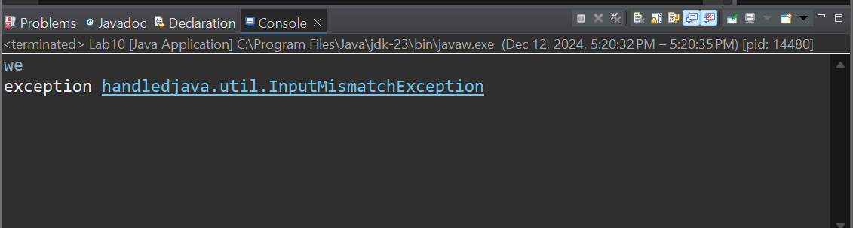

Custom Exception
package lab10;
import java.util.Scanner;

class customException{
static void validate(float salary) {
if(salary<0) {
throw new ArithmeticException("must be greater the zero");
}
else {
System.out.println("your salary is = "+salary);
}

}
}

public class task5 {

public static void main(String[] args) {

Scanner sc=new Scanner(System.in);

System.out.println("enter your salary: ");
float salary=sc.nextFloat();

customException.validate(salary);

sc.close();

}

}
Output:
